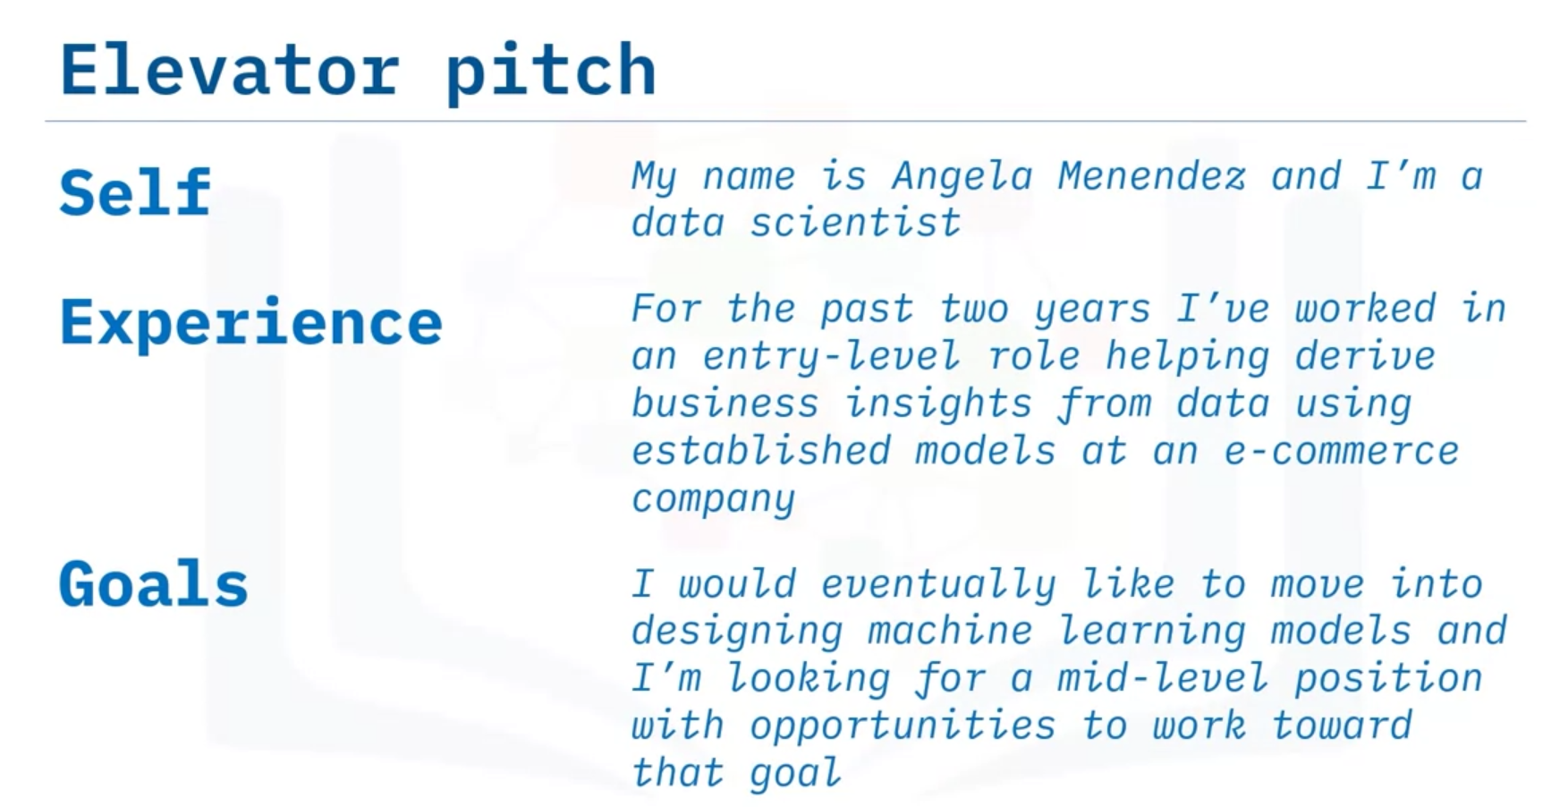

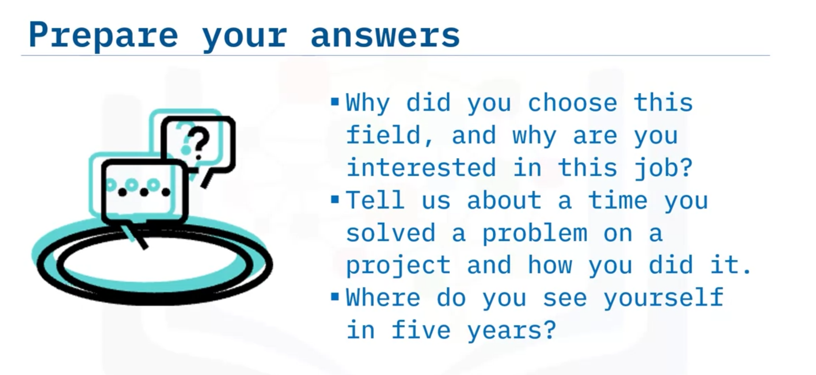

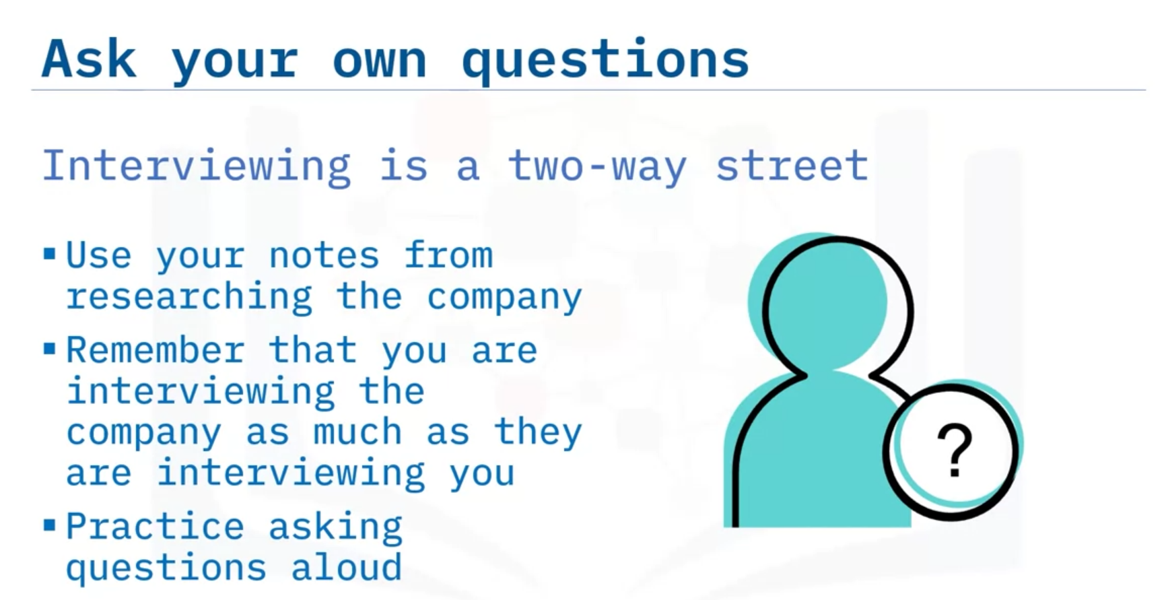

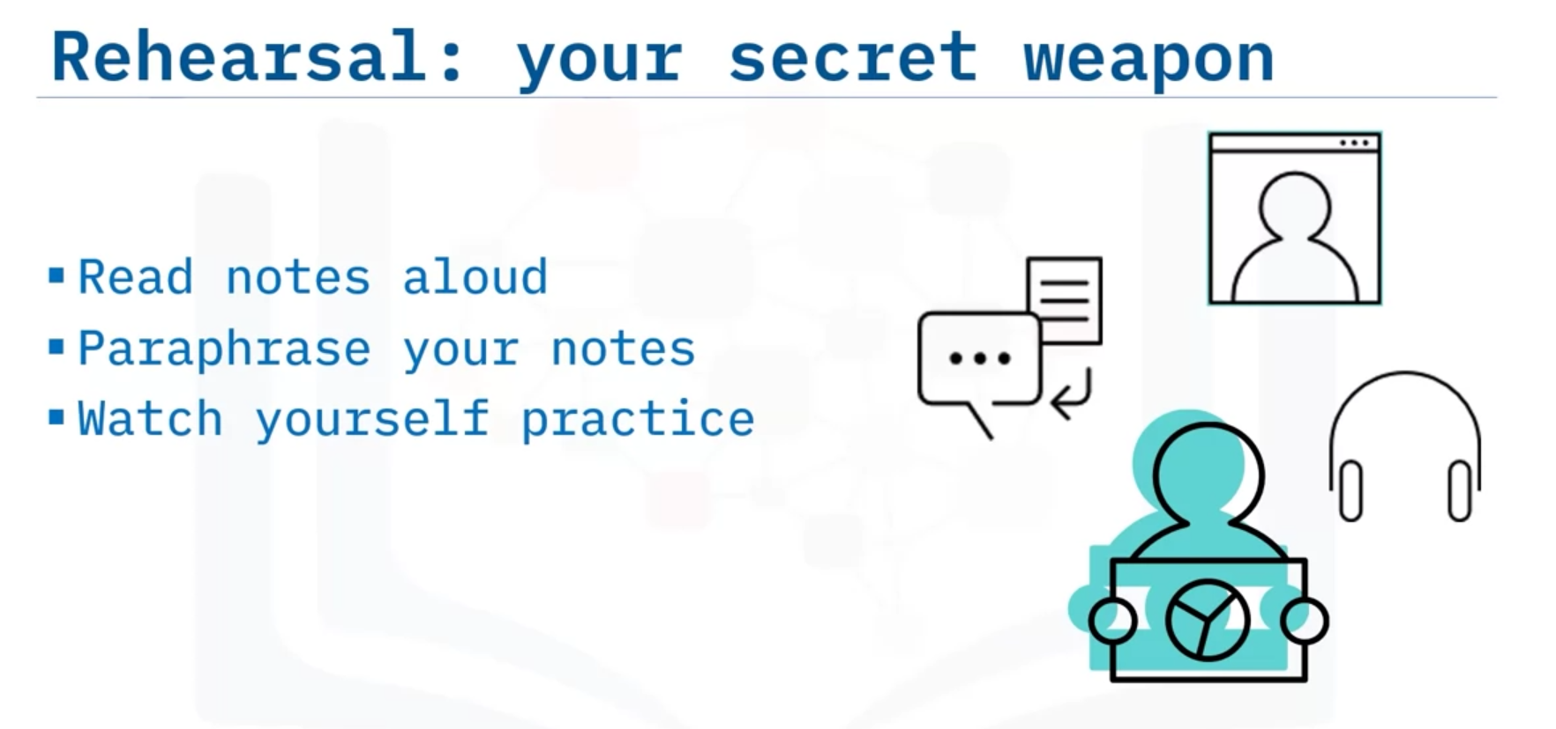

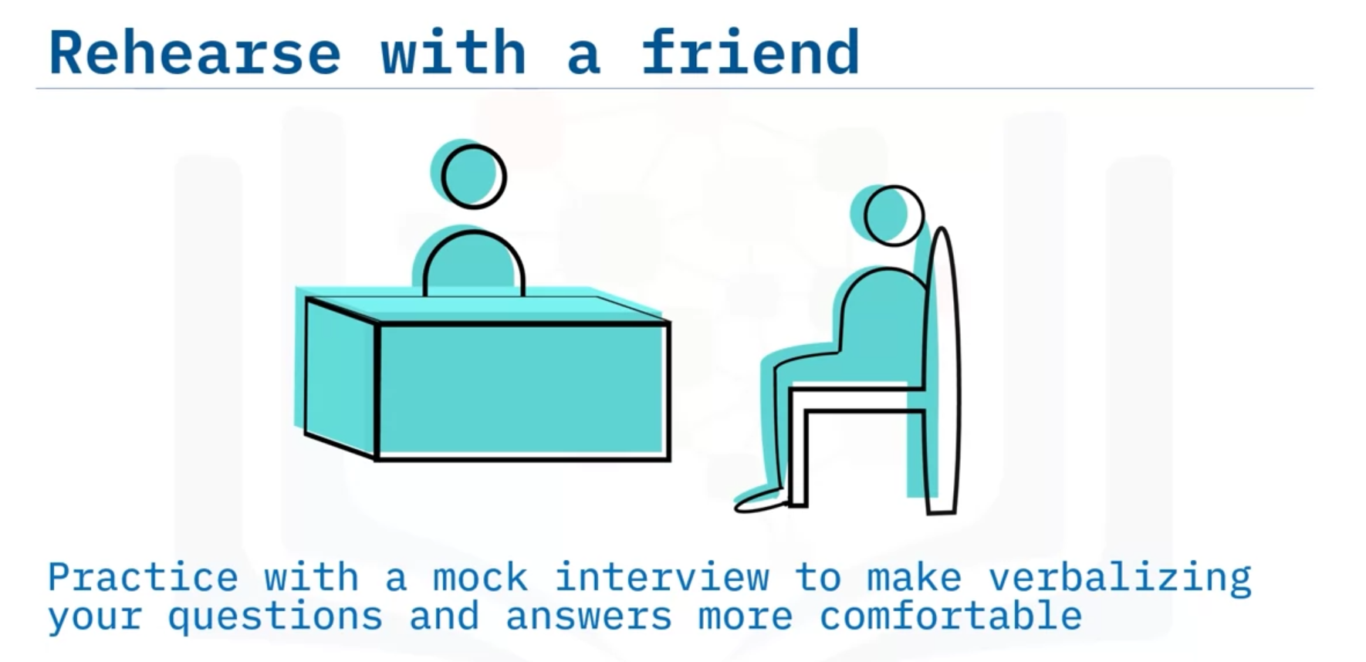

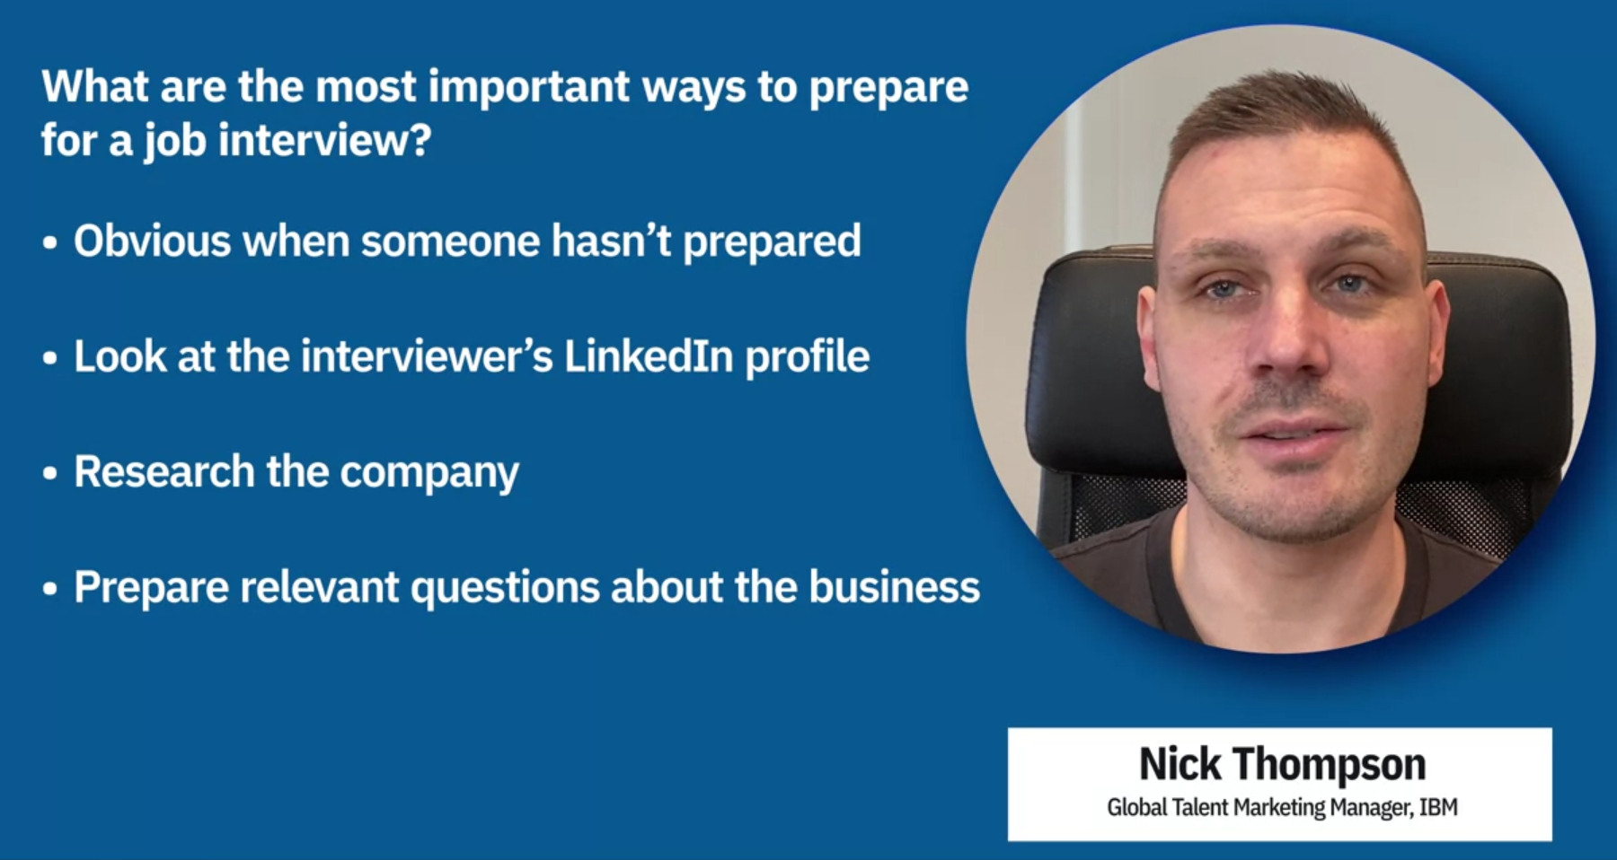

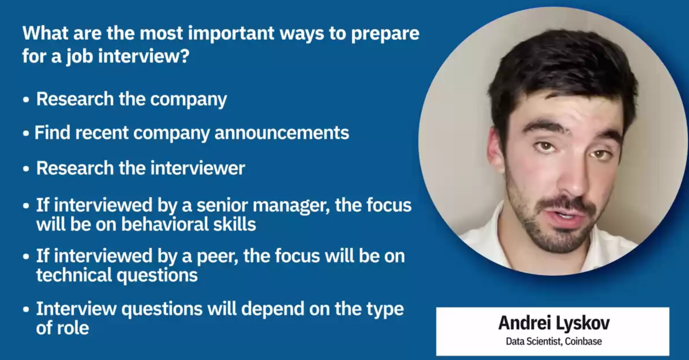

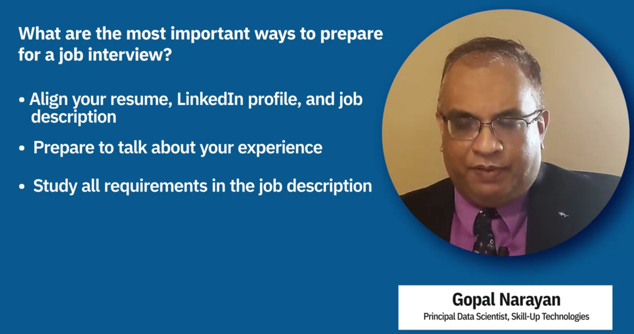

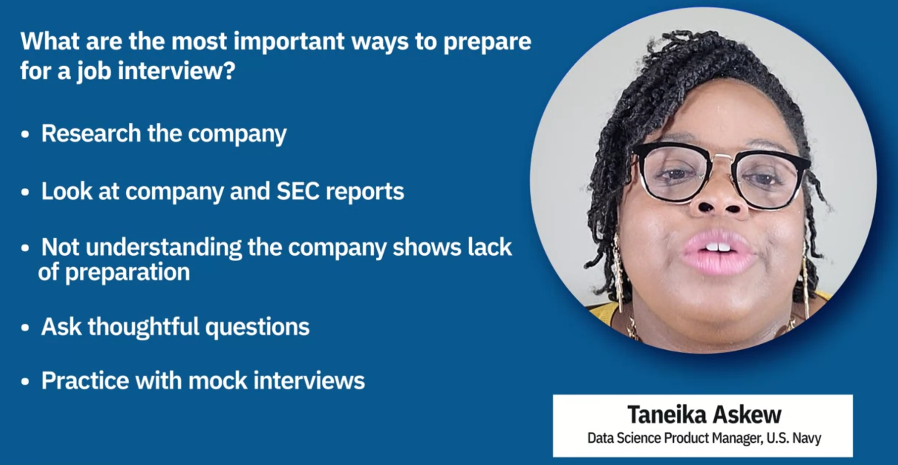

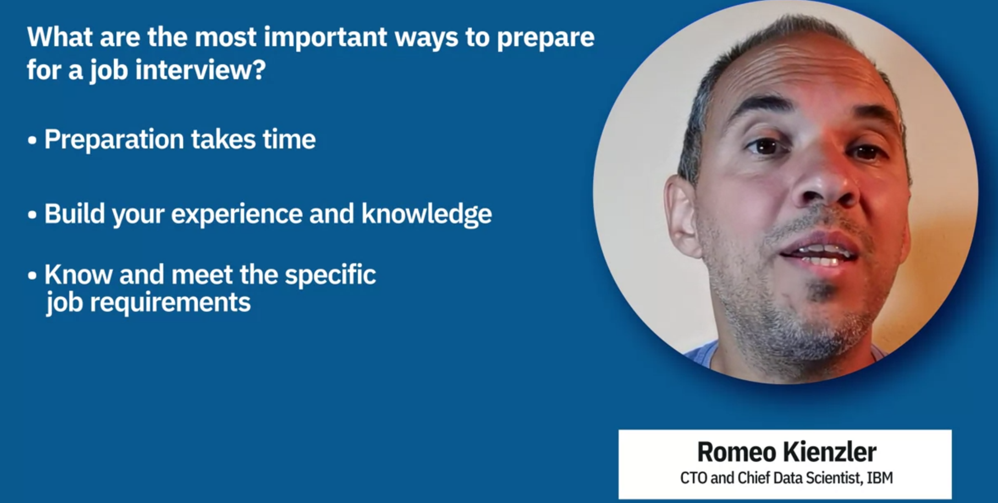

# Prepare for an Interview

**Estimated time needed:** 60 minutes

Welcome to the hands-on lab to prepare for an interview. In this lab, you will work on interviewing skills and think ahead to questions and answers you may encounter.

## Learning Objectives

After completing this lab, you will be able to:

* Deliver your elevator pitch smoothly.
* Answer common interview questions.
* Ask effective questions in interviews.

## Prerequisites

You will need the following to complete the exercises in this lab:

* Your elevator pitch (discussed in a previous lesson)
* Word processing software

## Keep in mind

* There’s a lot of difference between knowing information and being able to smoothly present it. You can bridge that gap by rehearsing your delivery and presentation. To develop the skill, you’ll need to tone up your body and voice with practice.

## Exercise 1: Practice your elevator pitch

In this exercise, you will practice delivering your elevator pitch.

1. Retrieve the elevator pitch that you composed in a previous lesson. To recap, an elevator pitch is a brief introduction of yourself and your goals.Essentially it should be about three or four sentences that include your name and title, your recent experience, and what you’re currently looking for in a job. This is useful for networking and answering questions like “tell us about yourself.” For example, you might say:

“My name is Angela Menendez and I’m a data scientist. For the past two years I’ve worked in an entry-level role helping derive business insights from data using established models at an e-commerce company. I would eventually like to move into designing machine learning models and I’m looking for a mid-level position with opportunities to work toward that goal.”

1. Read over your elevator pitch. Make sure you’re still satisfied with it and that it’s short and informative.
2. Memorize your elevator pitch and practice saying it until you’re comfortable recalling it when you need it.

## Exercise 2: Prepare answers for common questions

In this exercise, you will write possible answers for common interview questions.

Many of the questions in interviews are specific to that comapany and position. However, there are some questions you’ll encounter often. You’ll be more confident if you’ve prepared ahead to answer those questions.

1. Open new document in your word processor and copy the supplied questions into it.
2. For each question, consider an answer you might give. You could use your resume to remind you of situations you faced in previous roles.
3. Write in an answer for each question. Ensure your answers are professional and complete without being overly long.
4. Try reading the answers aloud, since you will be saying them in an interview. If you find phrasing that’s difficult to say, reword the answer.

### Sample interview questions

* What attracted you to the field of data science?
* Can you recall a time when you had very little time to complete a task? How did you approach getting it done?
* Tell me about a time you disagreed with a coworker, and how you resolved the conflict.
* What was your favorite previous project? Why did you like it?
* Can you remember a time you disagreed with your supervisor? How did you solve the problem?
* Describe a situation where you made a mistake, and what you did to resolve the effects.

## Exercise 3: Compose questions for interviewers

In this exercise, you will write questions that you can ask interviewers.

In most interviews, you will be asked at some point whether you have questions to ask. It’s always better to be prepared with some questions. It’s tempting to say no because it might seem polite, but you will make a better impression if you can show that you’ve thought about the company and the interview already.

1. Open a new document and consider what you may want to know about any company you might work for. Some examples are provided below, and you can think of your own. Be careful about asking questions about benefits and compensation too early in the interview process - leave it for negotiating an offer when you get one.
2. Again, practice saying these questions aloud. The more comfortable you can get with knowing and speaking the questions, the better you can listen to the answers.

As you prepare for a particular interview, you’ll want to use your company research notes to prepare more specific questions to add to the list.

Always be open to questions that will come up in your mind during interviews, and don’t hesitate to ask for clarification.

### Example questions for interviewers

* What is the structure of the team I would be joining, and what is its work style?
* What is the advancement path for this position in the company?
* What do you personally like about working for this company?
* How would you describe the organization’s culture?
* How do you evaluate success in this role?

## Take It Further

Now that you’ve done this preparation, you can go further to get ready for your interviews.

* Rehearse your questions and answers in front of a mirror. This will help you be more comfortable with saying your ideas aloud, and it will help you see if you have any habits or expressions to change because they may distract from what you’re saying. It will also help somewhat to prepare you to speak while facing other people.
* Record yourself in audio and video, so that you can review your performance and concentrate on how you can improve it, while you’re not involved in performing it at the same time.
* Enlist the help of a friend to do a mock interview where you can try out your questions and answers. You may even have your friend find new questions so that you can practice answering spontaneously. Your friend can also help you review your recordings.

## Tips

* If you have a cloud storage space like Google Docs or Dropbox, you may want to save your notes there so that you can always find it easily using any device and study again before interviews.

## Conclusion

Good work! You have prepared and rehearsed for your interviews, and you’ll be much more ready to make a great impression when your opportunity comes.